
PYTHON PROGRAMMING LAB FILE

Name: Krishna Som
Sap ID: 590025475
Batch: 34
Teacher: Sugandha Sharma

Objective: Pattern Printing
Write a program to print the following pattern
123454321
1234 *4321
123 * * 321
12 * * * 21
1 * * * * 1

Code:
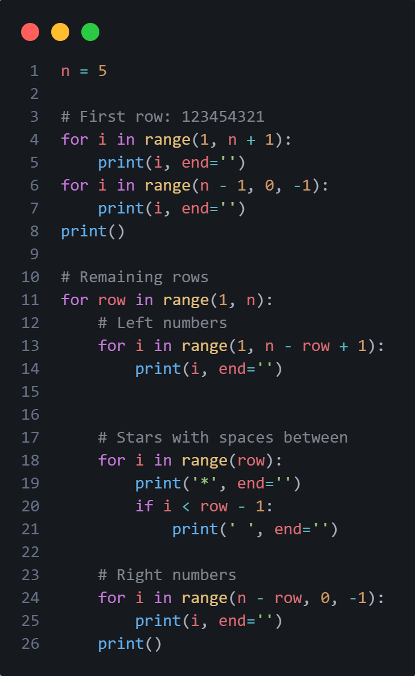

Output:
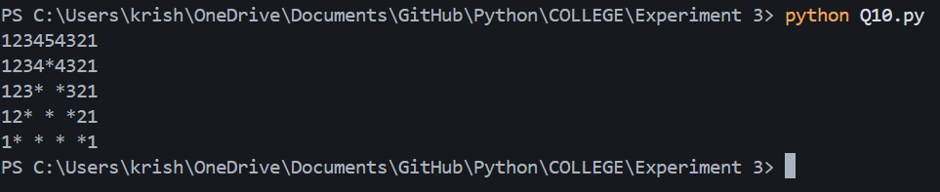

Objective 1: Find a factorial of given number.
Code:
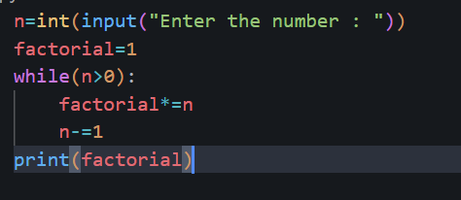
Output:
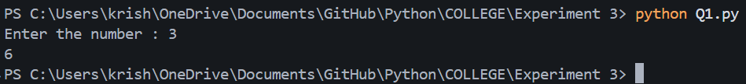

Objective 2: Find whether the given number is Armstrong number.
Code:
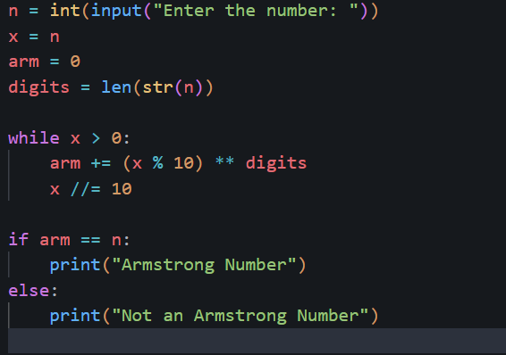
Output:
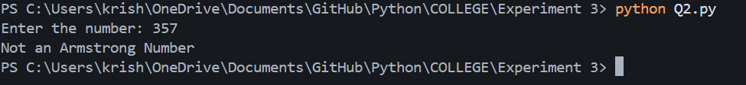

Objective 3:
Code:
Output:
Objective:
Code:
Output:
Objective:
Code:
Output:
Objective:
Code:
Output:
Objective:
Code:
Output:
Objective:
Code:
Output:
Objective:
Code:
Output:
Objective:
Code:
Output:
Objective:
Code:
Output:

